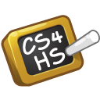
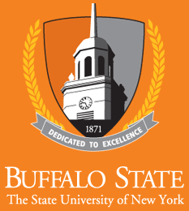

CS4HS

Third Annual Student Showcase and Competition
SUNY Buffalo State
May 30, 2015

Schedule

9:30 – 10:00: Set-up & Breakfast
Technology Building Lobby

10:00 – 11:00: Showcase & Competition

11:00 - 11:30: Student Interaction
Technology Building Lobby and Technology 140

11:30 - 12:00: Close-Down & Lunch
Technology 160

12:00 – 12:15: Address from D Feher of Google
Technology 160

12:15 - 12:45: Project Presentations
Technology 160

12:45 – 1:00 Award distribution
Technology 160

SUNY Buffalo State
1300 Elmwood Avenue
Buffalo, NY 14222

CS4HS

CS4HS is an annual grant program sponsored by Google promoting computer science education worldwide by connecting educators to the skills and resources they need to teach computer science & computational thinking concepts in fun and relevant ways. Our team at SUNY Buffalo State has been honored to present a workshop in the CS4HS program for over 50 Western New York Middle and High School teachers the past two summers. The CS4HS Student Showcase and Competition represents the results of a number of these teachers starting computer science clubs and offering computer science classes at their schools.

Event Organizers

- SUNY Buffalo State Faculty:

  - Dr. Neal Mazur
  - Dr. Sarbani Banerjee
  - Dr. Ramona Santa Maria
  - Dr. Barbara Sherman
  - Mr. Charles Arbutina
  - Mr. Andrew Garrity
  - Mr. James Gerland

- SUNY Buffalo State Students:

  - Mr. Omar Abdulrahman
  - Ms. Mercedes Brooks
  - Mr. Adam Doctor
  - Mr. Steve Maciejewski

- Buffalo State Staff:

  - Ms. Tammy Anna

Student Projects

- Casey Middle School

  - Zaid Arshad, Nick Barillari – Computer Program
Project Title: BTPSWP ( buttons that play songs when pressed )
Teacher Mentor: Larry Goble

  - Ethan King – Computer Game
Project Title: Mathematical Quest
Teacher Mentor: Larry Goble

  - Sayantika Roy, Prakriti Setlur – Web Page
Project Title: Think Bold: Power!
Teacher Mentor: Larry Goble

  - Joshua Jung – Computer Program
Project Title: Pixel Escape
Teacher Mentor: Larry Goble

  - Aryaa Deshpande, Yolanda Wang – Computer Game
Project Title: The Random Game
Teacher Mentor: Larry Goble

  - Ronald Vincent – Computer Game
Project Title: Math Chase
Teacher Mentor: Larry Goble

  - David Su – Computer Game
Project Title: Get the Element!
Teacher Mentor: Larry Goble

  - Connor Smith, Adam Klein – Computer Game
Project Title: Magical Math
Teacher Mentor: Larry Goble

  - Andrew Lin – Computer Game
Project Title: Making the Perfect Hamburger
Teacher Mentor: Larry Goble

  - Mustafa Gundroo – Computer Game
Project Title: Star Chase
Teacher Mentor: Larry Goble

  - Nick Masi – Computer Game
Project Title: Arduino Esplora Game
Teacher Mentor: Larry Goble

  - Maddie Nadrich – Robotics
Project Title: Color Sensing Robot
Teacher Mentor: Larry Goble

  - Miranda Peer, Sarah Nyaanga – Computer Game
Project Title: Piano Playing
Teacher Mentor: Larry Goble

  - Dina Nyaanga – Computer Game
Project Title: Fly Away
Teacher Mentor: Larry Goble

  - Anish Lakshman, Patrick Ames– Robotics
Project Title: Ollie Epic Tricks
Teacher Mentor: Larry Goble

  - Lucas Sommer – Computer Program
Project Title: Child Day
Teacher Mentor: Larry Goble

  - Sarmad Wahab – Robotics
Project Title: Aerodynamic Flying Model
Teacher Mentor: Larry Goble

- Cleveland Hill High School

  - Jared Renzi – Computer Programs
Project Title: GraphScript
Project Title: The Block Scheduler
Teacher Mentor: Steve Maranto

  - Elizabeth Metzger – Computer Program
Project Title: Gas and Wash
Teacher Mentor: Marcie McDougal-Domroes

  - Ryan Osswald – Robotics
Project Title: Ryan’s Really Rad Robot
Teacher Mentor: Steve Maranto

- North Tonawanda High School

  - Maxwell Cohn – Computer Program
Project Title: Word Search Generator
Teacher Mentor: Barb Sattelberg

  - Ariana Burns – Computer Program
Project Title: Music Maker
Teacher Mentor: Barb Sattelberg

- Williamsville North High School

  - Lisa Ni – Computer Game
Project Title: Bubble Trouble
Teacher Mentor: Julie Johnson

  - Casey Koenig – Computer Games
Project Title: Snake
Project Title: Chess Computer
Teacher Mentor: Julie Johnson

  - Bhaskar Roberts – Computer Program
Project Title: Cad-bury Chocolate
Teacher Mentor: Julie Johnson

  - Kathan Roberts, Ling Ming Kong – Robotics
Project Title: Dorm Defender
Teacher Mentor: Susan Recoon

- Nichols Middle School

  - Steven Hall – Computer Game
Project Title: Jake’s Adventure
Teacher Mentor: Tom Maynor

  - James Coburn, Kyan Chase – Computer Game
Project Title: Caveman Rush
Teacher Mentor: Tom Maynor

  - Rohit Rachala, Anu Kumar, Lucas Kiewick – Computer Game
Project Title: Dot Battle
Teacher Mentor: Tom Maynor

Thank You for Participating

Our sincerest thanks to all teachers, students, and guests who have participated in this event. We appreciate your support!

Sarbani, Neal, Barbara and Ramona

We would like to offer special thanks to our sponsors
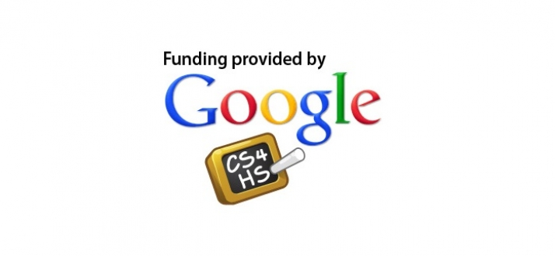

SUNY Buffalo State Office of Admissions

SUNY Buffalo State Computer Information Systems Department

