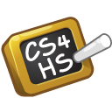
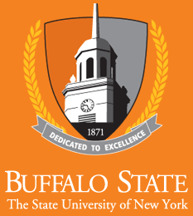

CS4HS

Eighth Annual Student Showcase and Competition
SUNY Buffalo State
June 6, 2020

Schedule

Event begins at 10:00 am, June 6, 2020
Zoom Meeting ID : 819 8816 3149

Welcome
Dr. Neal Mazur, Chair, Computer Information Systems Dept., Buffalo State

Introduction of Organizers

Introduction of Teacher/Mentors

Students, Schools, and Project Overview

Project Showcase

Student Certificate Presentation

Award Ceremony

Final Thoughts

SUNY Buffalo State
1300 Elmwood Avenue
Buffalo, NY 14222

CS4HS

CS4HS is an annual grant program sponsored by Google promoting computer science education worldwide by connecting educators to the skills and resources they need to teach computer science & computational thinking concepts in fun and relevant ways. Our team at SUNY Buffalo State has been honored to present a workshop in the CS4HS program for over 250 Western New York Middle and High School teachers for eight summers. The CS4HS Student Showcase and Competition represents the results of a number of these teachers starting computer science clubs or offering computer science classes at their schools.

Event Organizers

- SUNY Buffalo State Faculty:  - Dr. Neal Mazur  - Dr. Sarbani Banerjee  - Prof. Maria Garrity  - Prof. James Gerland  - Prof. Charles Arbutina  - Dr. Ramona Santa Maria  - Prof. Andrew Garrity  - Prof. Eric Nagel | - SUNY Buffalo State Student:  - Mr. Michael Grzeskowiak

Student Projects

- Allendale Columbia School

  - Mary Cotter – Poster
Project Title: Watching Our Water; Predicting Water Quality from Satellite Images
Teacher Mentor: Tina Duver

  - Ryan Mogauro – Computer Program
Project Title: Class Calculator
Teacher Mentor: Maya Crosby

- Buffalo Seminary

  - Angelina Myles – Computer Game
Project Title: Prior to the Pandemic (PTTP)
Teacher Mentor: Beth Adamczyk

  - Magdalen McColluch – Computer Program
Project Title: Dr. Magnus Hirschfeld Simulator
Teacher Mentor: Beth Adamczyk

  - Onvida Serixay – Computer Game
Project Title: Maps and Dimension Jumping
Teacher Mentor: Beth Adamczyk

  - Sasha Wittenbrink – Computer Program
Project Title: Home Run
Teacher Mentors: Beth Adamczyk

- Nardin High School

  - Lenore Brown – Computer Game
Project Title: Snake Game
Teacher Mentor: Pam Healy

  - Christina Nowicki – Computer Program
Project Title: Recipe Revealer - What Should You Make for Dinner?
Teacher Mentor: Pam Healy

  - Carys Popat – Computer Game
Project Title: Addition Game
Teacher Mentor: Pam Healy

  - Tess Trammell – Computer Game
Project Title: Guess that Celebrity
Teacher Mentor: Pam Healy

- Transit Middle School

  - Joshua Becker – Web Design
Project Title: SmartStocks
Teacher Mentor: Larry Goble

  - Ridhi Garg – Robotics
Project Title: Sol Bot
Teacher Mentor: Larry Goble

  - Monal Gupta, Jasmitha Keesara – Web Design
Project Title: J and M Blog
Teacher Mentor: Larry Goble

  - Arjun Kodial, Zyad Zahra – Robotics
Project Title: Zyad and Arjun's Amazing World Introduction to the Vent Crawler
Teacher Mentor: Larry Goble

  - Alex Liang, Eric Liu– Computer Game
Project Title: Presidential Pandemic
Teacher Mentor: Larry Goble

  - Ananth Narayan –Robotics
Project Title: “The Joystick” Smart Car
Teacher Mentor: Larry Goble

  - Alexander Smith – Computer Game
Project Title: Brim
Teacher Mentor: Larry Goble

- University High School

  - Sirihaasa Nallamothu – Computer Program
Project Title: LeukosCognosis: A Machine Learning Algorithm to Diagnose Leukemia
Teacher Mentor: Sateesh Nallomothu, Cory Culbertson

- West Seneca Christian School

  - Allison Gummo – Computer Program
Project Title: Learning Animal Sounds
Teacher Mentor: Orlando Buria

  - Faith Gummo – Computer Program
Project Title: Down Home Yum
Teacher Mentor: Orlando Buria

  - Alyssa Hagelberger – Computer Program
Project Title: Where would you like to shop?
Teacher Mentor: Orlando Buria

  - Rachel Mohr – Computer Game
Project Title: My Garden
Teacher Mentor: Orlando Buria

  - Ethan Szczygiel – Computer Game
Project Title: A Clicker Game
Teacher Mentor: Orlando Buria

  - Sierra Wiesmore – Computer Program
Project Title: States and Capitals
Teacher Mentor: Orlando Buria

  - Sarah Zolnowski – Computer Program
Project Title: Animal Quiz
Teacher Mentor: Orlando Buria

- Williamsville North High School

  - Zaid Arshad – Web Design
Project Title: Note-Share
Teacher Mentor: Julie Johnson

  - Nick Masi – Computer Program
Project Title: Hand-E Timer
Teacher Mentor: Julie Johnson

- WNY Maritime Charter

  - David Wright, Joshua Pearson – Robotics
Project Title: Robotics Grocery Delivery
Teacher Mentor: Kevin Gee

  - Madalyn Lucas – Web Design
Project Title: Robotics Grocery Delivery Website
Teacher Mentor: Kevin Gee

Thank You for Participating

Our sincerest thanks to all teachers, students, judges, guests and Buffalo State Student Assistants who have participated in this event. We appreciate your support!

~ Neal and Sarbani

We would like to offer special thanks to our sponsors:
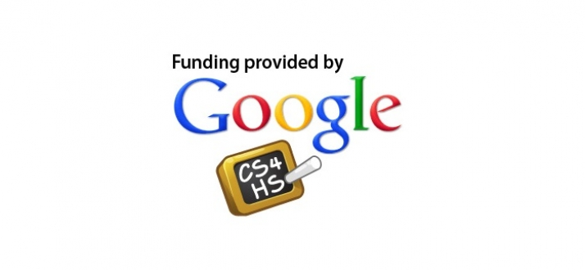
SUNY Buffalo State Office of Admissions

SUNY Buffalo State Computer Information Systems Department

